Shadi Jiha #40131284 25/01/2020

Winter 2020 Assignment 1

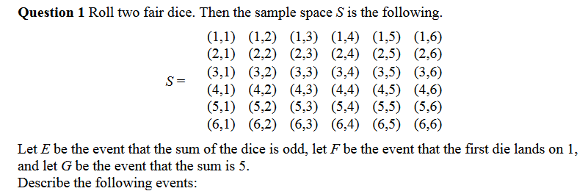**COMP 233 Assignment 1 Solution**

Solution:

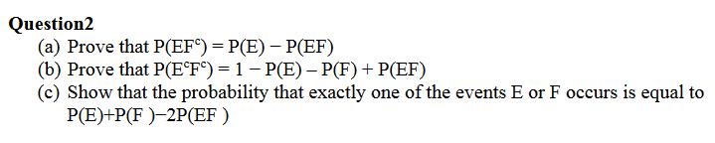

Solution:

1. 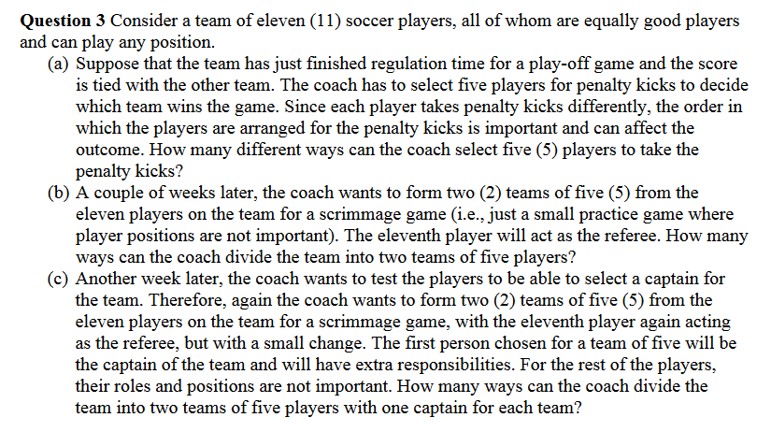The probability that exactly 1 of the events E or F occurs is equal to the union of both events minus their intersection. Which translates to:

Solution:

1. ways
2. ways

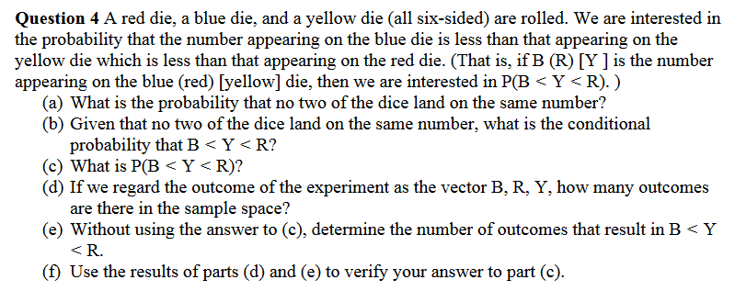Solution:

1. 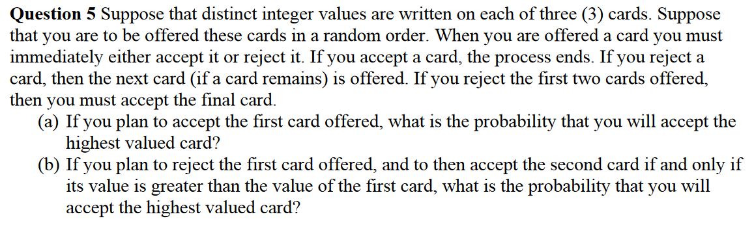

Solution:

1. Let A: Probability to Accept second card

Let H: Probability that second Card is higher than the first one

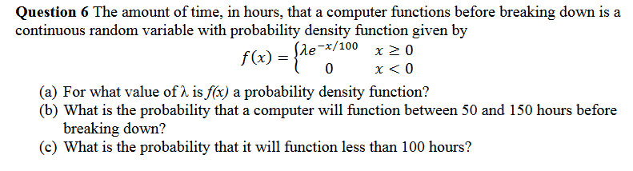Solution:

1. We observe that is non-negative if is so:

For this function will be a PDF

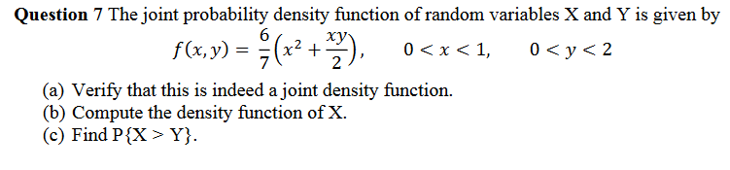

1. is a joint density function if the area under the curve is = to 1. Therefor:

Hence this function is a joint density function

1. Integrate over :
2. . And thus, we have: